DBMS LAB4
Anmol Keswani_ECS_D6-68
Aim: To implement and execute advanced SQL queries on a relational database using joins, subqueries, set operations, aggregate functions, grouping, and conditional operators for effective data retrieval and analysis.
Q1. Find match Ids of all the matches in the database in which Tendulkar batted.
mysql> SELECT MatchID FROM Batting, Player;
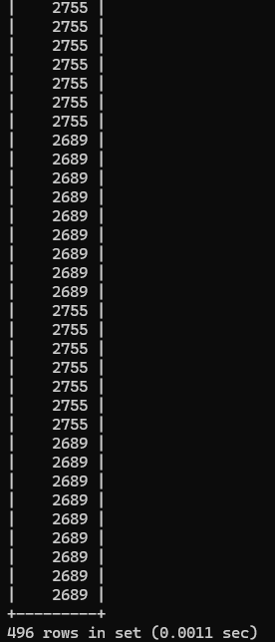
mysql> SELECT MatchID FROM Batting,Player WHERE PID=PlayerID;
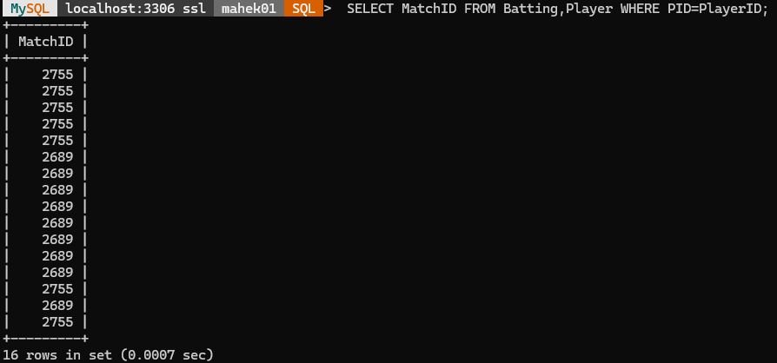
mysql> SELECT MatchID FROM Batting,Player WHERE PID=PlayerID AND Lname='Tendulkar';
OR
mysql> SELECT MatchID FROM Batting WHERE PID IN (SELECT PlayerID FROM Player WHERE LName='Tendulkar');
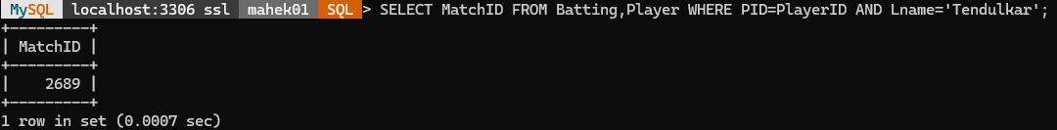
Q2. Find match information of all matches in which Dohni has batted.
mysql> SELECT Team1,Team2,Ground,Date FROM ODIMatch,Batting,Player;
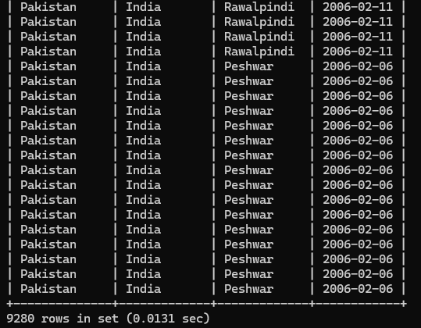
mysql> SELECT Team1,Team2,Ground,Date FROM ODIMatch WHERE MatchID IN (SELECT MatchID FROM Batting WHERE PID IN (SELECT PlayerID FROM Player WHERE LName ='Dhoni'));
OR
Using Join
mysql> SELECT Team1,Team2,Ground,Date FROM ODIMatch,Batting,Player WHERE ODIMatch.MatchID=Batting.MatchID AND PlayerID=PID AND LName='Dhoni';
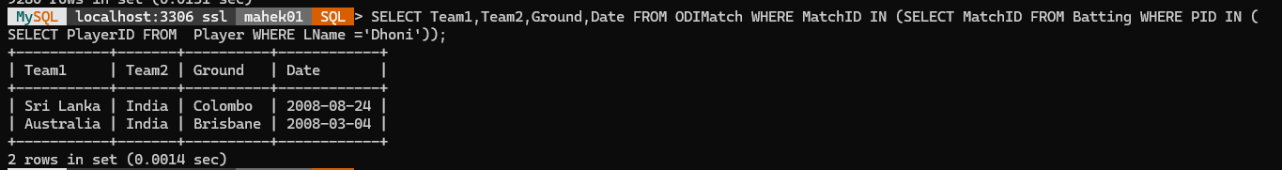
Q3. Find match Ids of all matches in which Tendulkar batted.
mysql> SELECT MatchID FROM Batting WHERE PID IN (SELECT PlayerID FROM Player WHERE Lname='Tendulkar');
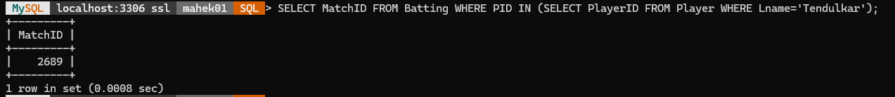

Q4. Find Ids of all players that have both bowled and batted in the ODI match 2689
mysql> SELECT PID FROM Batting WHERE MatchID=2689 AND PID IN (SELECT PID FROM Bowling WHERE MatchID=2689);
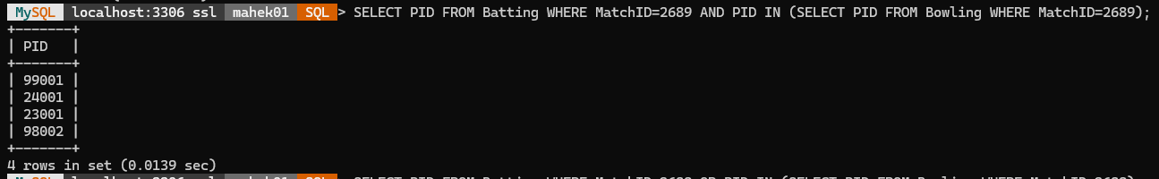
Q5. Find Ids of all players that have either bowled or batted (or did both) in ODI match 2689
mysql> SELECT PID FROM Batting WHERE MatchID=2689 OR PID IN (SELECT PID FROM Bowling WHERE MatchID=2689);
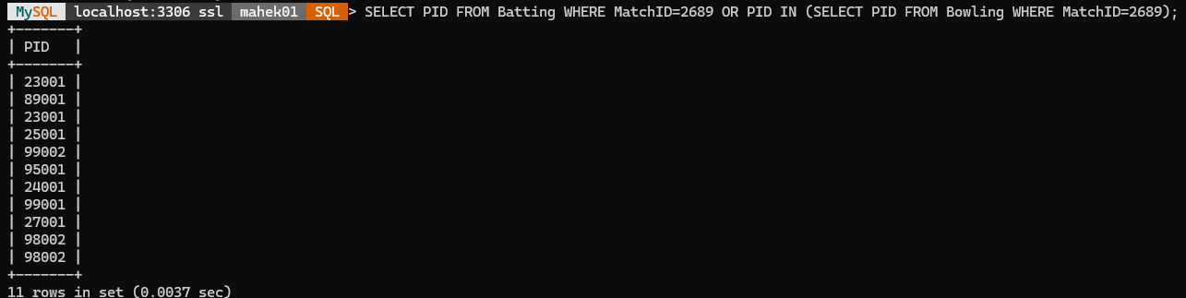
Using Union
mysql> SELECT PID FROM Batting WHERE MatchID=2689 UNION (SELECT PID FROM Bowling WHERE MatchID=2689);
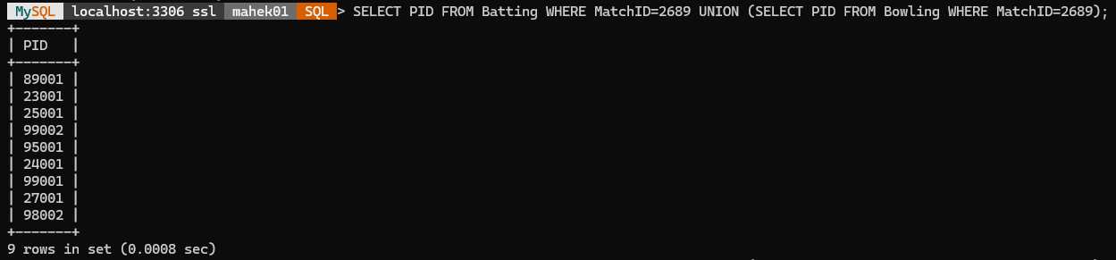
Q6. Find Ids
mysql> SELECT PID FROM Batting WHERE MatchID=2689 AND PID NOT IN (SELECT PID FROM Bowling WHERE MatchID=2689);
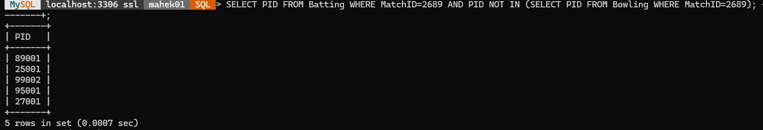

Q7. Find match Ids where Tendulkar has played.
mysql> SELECT MatchID FROM Batting,(SELECT PlayerID FROM Player WHERE LName='Tendulkar') ST WHERE PID=ST.PlayerID;
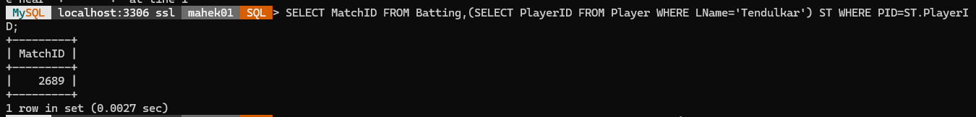
Q8.Find match Ids of all those matches in which player 27001 bats and makes more runs than he made at every match he played at Colombo
mysql> SELECT MatchID FROM Batting WHERE PID=27001 AND NRuns > ALL (SELECT NRuns FROM Batting WHERE PID=27001 AND MatchID IN (SELECT MatchID FROM ODIMatch WHERE Ground='Colombo'));
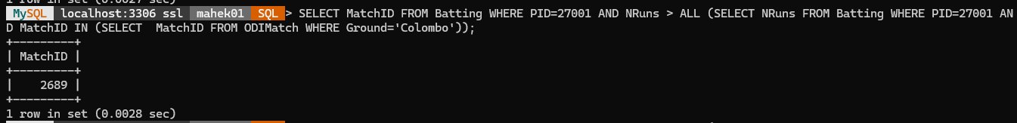
Q9. Find match Ids of all those matches in which player 27001 has scored minimum runs than he made at every match he played at Brisbane
mysql> SELECT MatchID FROM Batting WHERE PID=27001 AND NRuns < ALL (SELECT NRuns FROM Batting WHERE PID=27001 AND MatchID IN (SELECT MatchID FROM ODIMatch WHERE Ground='Brisbane'));
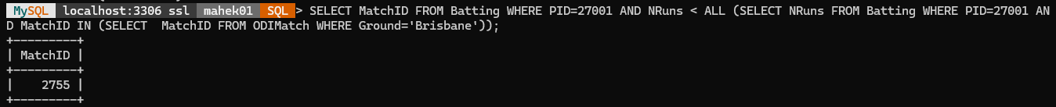
Q10(a). Find Ids and scores of players who scored less than 75 but more than 50 in Colombo.
mysql> SELECT PID,NRuns FROM Batting WHERE NRuns BETWEEN 51 AND 74 AND MatchID IN (SELECT MatchID FROM ODIMatch WHERE Ground='Colombo');
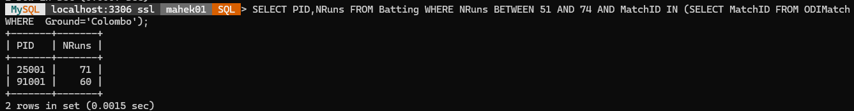
Q10(b). Find Ids and scores of players who scored greater than 49 runs in Colombo.
mysql> SELECT PID,NRuns FROM Batting WHERE NRuns > 49 AND MatchID IN (SELECT MatchID FROM ODIMatch WHERE Ground='Colombo');
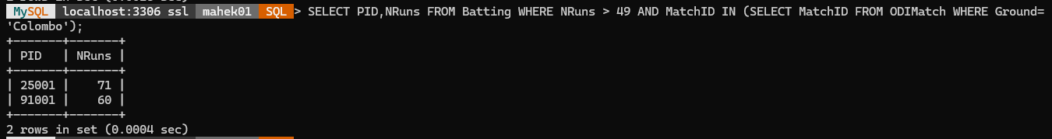
Q11. Find the player Ids of those players whose date of first match (FTest) is not given in the database.
mysql> SELECT PlayerID FROM Player WHERE FTest IS NULL;
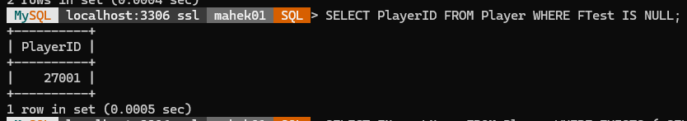
Q12. Find names of the player who batted in match 2689
mysql> SELECT FName,LName FROM Player WHERE EXISTS ( SELECT * FROM Batting WHERE PlayerID=PID AND MatchID=2689);
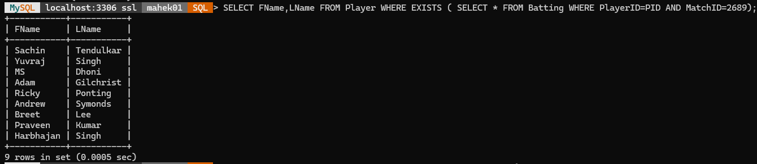
Q13. Find player Ids of players who have scored more than 30 in every ODI match that they have played.
mysql> SELECT PID AS PlayerID FROM Batting b1 WHERE NOT EXISTS (SELECT * FROM Batting b2 WHERE b1.PID=b2.PID AND NRuns < 31);
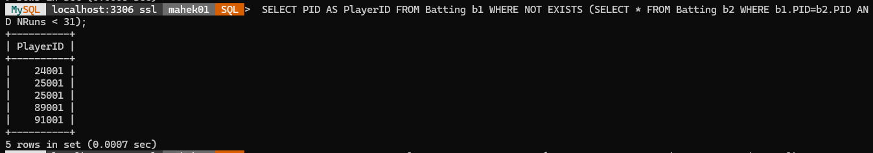
Q14. Find the names of players that have batted in all the ODI matches in Melbourne that are in the database.
SELECT FName, LName FROM Player WHERE NOT EXISTS (SELECT * FROM ODIMatch WHERE Ground = 'Melbourne' AND NOT EXISTS (SELECT * FROM Batting WHERE Batting.PID = Player.PlayerID AND Batting.MatchID = ODIMatch.MatchID));
Q15. Find the number of players that bowled in ODI match 2689
mysql> SELECT COUNT(*) AS NBowlers FROM Bowling WHERE MatchID=2689;
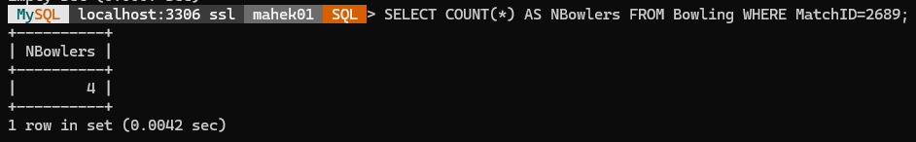

Q16. Find the average batting score of all the players that batted in the ODI Match 2689
mysql> SELECT AVG(NRuns) AS AvgRuns_2689 FROM Batting WHERE MatchID=2689;
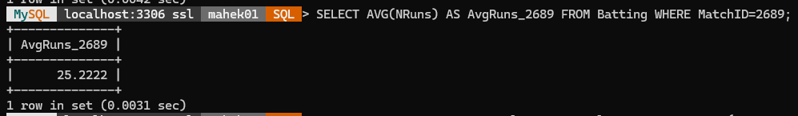
Q17. Find the youngest player in the database
mysql> SELECT FName AS Youngest_Player FROM Player WHERE YBorn=(SELECT MAX(YBorn) FROM Player);
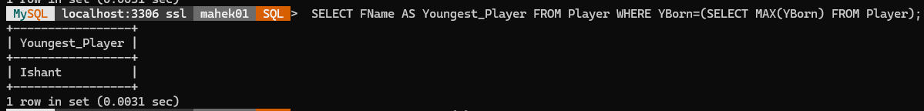
Q18. Find the number of players in the database from each country
mysql> SELECT Country, COUNT(*) AS NPlayers FROM Player GROUP BY Country;
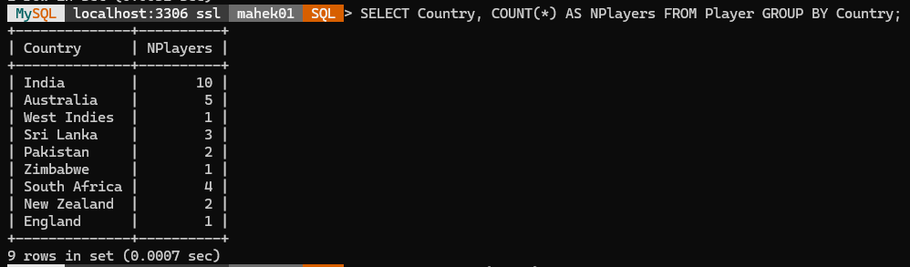
Q19. Find batting average of each player in the database. Present the PID of each Player.
mysql> SELECT PID,AVG(NRuns) AS AVGR FROM Batting GROUP BY PID;
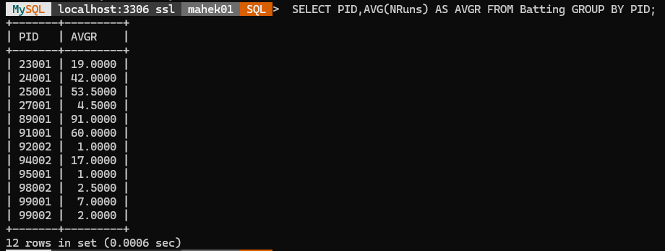

Solve the following
Q20. Find the batting average of each player from India in the database. Present first name of each player.
mysql> SELECT P.FName, SUM(B.NRuns) / COUNT(B.MatchID) AS Batting_Average FROM Player P JOIN Batting B ON P.PlayerID = B.PID WHERE P.Country = 'India' GROUP BY P.PlayerID, P.FName;
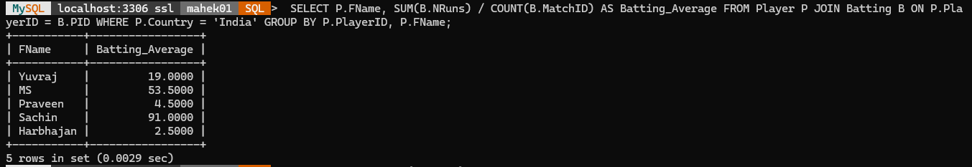
Q21. Find the average score for each player when playing against Australia
SELECT P.FName, AVG(B.NRuns) AS Average_Score FROM Player P JOIN Batting B ON P.PlayerID = B.PID JOIN ODIMatch M ON B.MatchID = M.MatchID WHERE M.Team1 = 'Australia' OR M.Team2 = 'Australia' GROUP BY P.PlayerID, P.FName;
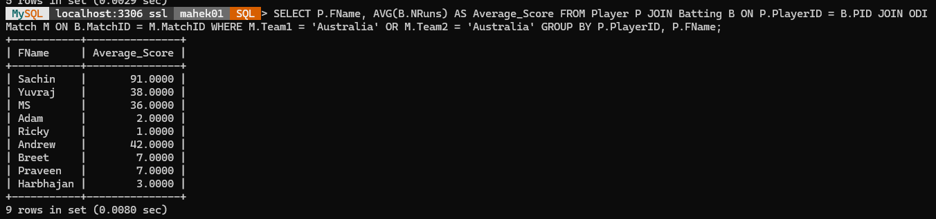
Q22. Find the ID of players that had a higher average score for all players when they played against Sri Lanka.
SELECT B.PID FROM Batting B JOIN ODIMatch M ON B.MatchID = M.MatchID WHERE M.Team1 = 'Sri Lanka' OR M.Team2 = 'Sri Lanka' GROUP BY B.PID HAVING AVG(B.NRuns) = (SELECT MAX(AvgScore) FROM (SELECT AVG(B2.NRuns) AS AvgScore FROM Batting B2 JOIN ODIMatch M2 ON B2.MatchID = M2.MatchID WHERE M2.Team1 = 'Sri Lanka' OR M2.Team2 = 'Sri Lanka' GROUP BY B2.PID) AS Averages);
